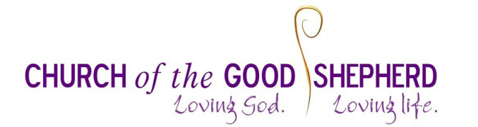
Friday Night Youth Group at Church of the Good Shepherd
(Formerly known as Clubnight)
Registration and Consent form (2016/2017)
Childs Full Name:
Preferred name (if applicable) |  | Parent/Guardian Name:
Date of Birth |  | Email
Home Address |  | Address  (if different)
Post Code |  | Telephone (Home)
School Attended |  | Telephone (Mobile)

Medical / Health Details
Doctors Name/Surgery: | Doctors Telephone Number:
Does your child have any food or medical allergies (e.g. Nuts, Gluten, Additives, Penicillin) or any special dietary requirements?
Does your child have any medical conditions that might limit their involvement with active games or activities (i.e. asthma)?
Does your child have any learning or behavioural difficulties that it is important for us to know about?

Parental / Guardian Consent – Please circle YES or NO for each section
I consent for my child to take part in all normal activities of the Friday Night youth group, reading the programme and notifying the leaders of any potential difficulties. | YES / NO
I consent for photographs/video to be taken of my child to advertise the youth work of the church. | YES / NO
In the event of you not being able to contact me in an emergency, I give my permission for emergency medical treatment to be given to the above named person as necessary. | YES / NO
I consent for the above details about my child to be stored on computer and to be used for planning and organising purposes. The full details will only be disclosed to the children’s/youth co-ordination team and relevant group leaders. | YES / NO
I understand the church is responsible for the supervision of my child only during the time the group is in session. I understand that at all other times my child is my responsibility. | YES / NO

I understand that if my child does not behave and adhere to the Young Persons YES / NO
Participation Agreement, they will be sent home.
I agree to be fully contactable in the case where my child needs to be collected. YES / NO
I give permission for my child to walk home on their own after the session. YES / NO

Signature of Parent / Guardian: _________________________________________ Date: _________

Please have your child fill in this agreement:
Friday Night Youth Group at Church of the Good Shepherd
(Formerly known as Clubnight)
Young Persons Participation Agreement 2016/2017
Please Circle YES or NO for each section
I agree to take part in the set activity of each evening I attend. I understand that if I do not want to take part in a specific activity, I have the option not to attend that evenings session. | YES / NO
I will respect the Leaders of the Group, listen to their instruction and follow their instructions. | YES / NO
I will respect the other young people who attend this group, and will not be involved in bullying or fighting. | YES / NO
I will respect the Church building, and not cause damage to the space around me. | YES / NO
I agree to stay in the group for the session times, and not wander on and off church property. | YES / NO
I will not bring knives, drugs or alcohol onto the church premises. | YES / NO
I understand that if I do not behave and adhere to this Agreement, then I will be sent home | YES / NO

Signature of Young person: _________________________________________ Date: _________

If you have any difficulties filling in this form, please contact:
Abigail Edwards – Pioneer Community Worker
T 07504 099 439 E community@goodshepherdchurch.org.uk
DATA PROTECTION:
Any data held about your child will be held securely, and will be used for planning and administration purposes, and will be handled sensitively and securely, in accordance with the confidentiality requirements of the Data Protection Act 1988. These details will be deleted from the data system when the child is no longer an active participant in the Youth Group.

